**Cognitive, Pathological and Prognostic Profiles of Different Brain Ages in the Early Alzheimer’s Disease Continuum**

E. Doering1,2, G. Antonopoulos3,5, M. C. Hönig1,4, T. van Eimeren1,2, M. Daamen², H. Boecker², F. Jessen2,6, E. Düzel7, S. B. Eickhoff3,5, K. R. Patil3,5+, A. Drzezga1,2,4+ for the Alzheimer’s Disease Neuroimaging Initiative[1]

1University Hospital Cologne, Clinic and Policlinic for Nuclear Medicine, Cologne, Germany, 2German Center for Neurodegenerative Diseases (DZNE), Bonn, Germany, 3Research Center Juelich, Brain and Behavior (INM-7), Juelich, Germany, 4 Research Center Juelich, Molecular Organization of the Brain (INM-2), Juelich, Germany, 5Heinrich-Heine-University, Institute of Systems Neuroscience, Duesseldorf, Germany, 6University Hospital Cologne, Department of Psychiatry, Cologne, Germany, 7German Center for Neurodegenerative Diseases (DZNE), Magdeburg, Germany

Correspondence: E. Doering, Kerpener Str. 62, 50937 Köln, GERMANY, phone: (+49) 0221 478 7503, fax: (+49) 0221 748 7639, email: elena.doering@uk-koeln.de

Keywords: machine learning, cognitive impairment, neuroimaging

Brain aging is characterized by anatomical and molecular changes. Brain age can differ from chronological age (“brain age gap”, *BAG*); and this difference, typically estimated from structural MRI, is associated with various intracerebral abnormalities, such as e.g. observed in Alzheimer’s disease (AD). 18F-Fluorodeoxyglucose PET (FDG-PET) is considered to represent an earlier indicator of neurodegeneration compared to structural MRI. Possibly, processes associated with brain aging are captured by FDG-PET with greater sensitivity compared to structural MRI. Here, we compare the accuracy of brain age estimation from FDG-PET and structural MRI, and we associate BAG derived each modality with cognitive impairment and AD biomarkers. Furthermore, we present cutoffs for the prediction of cognitive outcome after two years. Analyses were conducted in individuals without (CN), with subjective cognitive decline (SCD) and with mild cognitive impairment (MCI).

**Methods**: Machine learning algorithms were trained to estimate brain age from 376 matched T1-weighted MRI or FDG-PET scans of CN+SCD from the Alzheimer’s Disease Neuroimaging Initiative and validated in internal and external test sets. BAG was correlated with measures of amyloid and tau pathology in CN+SCD and MCI (n=596). Finally, BAG was used to predict cognitive outcome after two years using logistic regression. Cutoffs for cognitive decline were estimated from the logistic regression output.

**Results**: FDG-PET (mean absolute error, *MAE*=2.46 years) and MRI (MAE=1.96 years) both estimated chronological age well. Both, FDG-PET- and MRI-derived BAG were correlated with amyloid load across groups and with cognitive performance in MCI. FDG-PET-derived BAG exceeding 0.85 years was indicative of pending cognitive impairment in CN+SCD, while an MRI-derived BAG beyond 2.23 years suggested development of dementia in MCI. BAG from the respective other modality was not/less indicative of cognitive outcome.

**Conclusion**:

Brain age is reliably estimated from FDG-PET or MRI. FDG-PET-derived BAG is more sensitive to early intracerebral changes related to cognitive deterioration in CN+SCD, while early features indicative of impending dementia in MCI are better reflected by MRI-derived BAG.

RUNNING TITLE: FDG-PET or MRI for Brain Age Estimation

**Graphical Abstract**

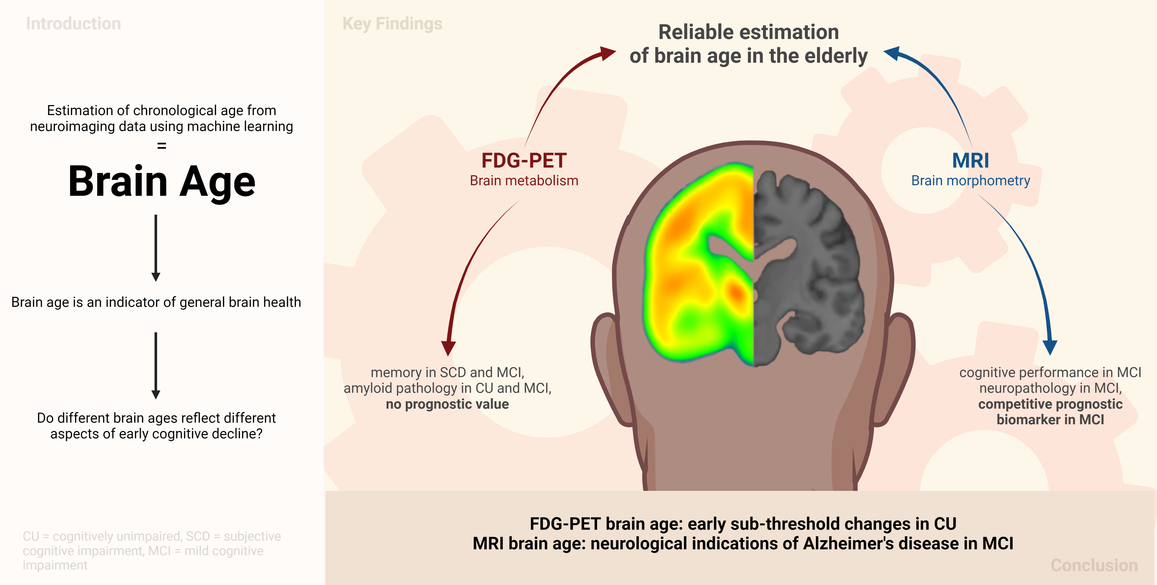

**1 Introduction**

Brain aging entails changes in cognitive performance, as well as brain function and structural parameters of brain integrity. Brain age can be modeled using machine learning algorithms by estimating a person’s chronological age from their neuroimaging data. Deviations of brain age from chronological age (the *brain age gap, “BAG”*) are associated with a variety of neurological conditions. Of special interest in this research field are neurodegenerative disease, including the Alzheimer’s disease (AD) continuum1–3. A recent study1 showed that BAG is associated with positron emission tomography (PET) AD biomarkers in patients with mild cognitive impairment (MCI), and that BAG is significantly elevated in individuals with impending cognitive deterioration/AD. These results motivate further research into the unique contribution of BAG as a marker of brain health and as a prognostic biomarker of cognitive impairment in the early stages of AD (MCI and subjective cognitive decline (SCD)).

Age-related changes in the brain are most evident in the brain’s anatomy, such as loss of brain volume (atrophy), and metabolism (neuronal dysfunction). Brain atrophy and metabolism can be quantified by T1-weighted magnetic resonance imaging (MRI) and 18F-Fluorodeoxyglucose-PET (FDG-PET), respectively. FDG-PET is considered to be an earlier indicator of neurodegeneration compared to structural MRI, as neuronal dysfunction precedes atrophy (i.e., neuronal loss) and regional proneness to the aging process is different when observed with FDG-PET or MRI4. It can therefore be assumed that different age- or disease-related processes are captured by the two modalities. To date, however, brain age estimation, in the vast majority of cases, is performed using MRI rather than FDG-PET. Only one recent study compared the two modalities and showed slightly better performance when using FDG-PET1. However, in this study, FDG-PET was not investigated independently of MRI, as FDG-PET was preprocessed using partial volume correction. This argues for further exploration of FDG-PET-derived BAG, and its potentially superior performance in delineating the earliest deviations from normal aging when cognitive impairment is not yet evident.

Here, we investigated the potential of FDG-PET and MRI separately as input for brain age estimation, with a particular focus on the early stages of the AD continuum. First, we estimated brain age in cohorts of individuals who were either cognitively normal (CN), had subjective cognitive decline (SCD), or mild cognitive impairment (MCI). Second, we calculated BAG and compared associations of FDG-PET- and MRI-derived BAG with cognitive performance and AD neuropathology in these cohorts. Finally, we evaluated the prognostic capacity of BAG for the prediction of cognitive outcome by using a logistic regression classifier to predict cognitive outcome from BAG and established risk factors of cognitive decline.

**2 Methods**

**2.1 Participants**

Baseline T1-weighted MRI and FDG-PET scans of 276 CN (*CNADNI*) whose MRI and FDG-PET scans were less than a year apart (mean = 30 days, SD = 23 days) were acquired from the Alzheimer's Disease Neuroimaging Initiative (ADNI) database ([adni.loni.usc.edu](https://ida.loni.usc.edu/collaboration/access/adni.loni.usc.edu)) to train our brain age estimation frameworks. The primary goal of the ADNI study has been to test whether biological markers and clinical and neuropsychological assessments can be combined to measure the progression of MCI and dementia. An additional 49 MRI and FDG-PET scans of CN were acquired from the Open Access of Imaging Studies-3 database5 (OASIS-3, https://www.oasis-brains.org/, *CNOASIS*) to validate the models in an external dataset (within-group, out-of-sample validation). Finally, we assessed brain age in SCD and MCI patient groups from the ADNI (out-of-group, within-sample), OASIS-3 and DZNE-Longitudinal Cognitive Impairment and Dementia Study6 (DELCODE) studies (out-of-group, out-of-sample) for an overview, see **Table 1**). To be included, participants in all samples had to be older than 60 years at the time of their scan. CN, SCD and MCI diagnoses from ADNI, OASIS, and DELCODE followed the current recommendations for the respective groups7,8 (details provided in the Supplementary Materials (SM) section 1a).

**2.2 Acquisition & Preprocessing of MRI and FDG-PET Scans**

FDG-PET scans in ADNI and OASIS were acquired dynamically 30-60 minutes (6x5 min frames) after injection with an average dose of 185 MBq (5 mCi). The DELCODE FDG-PET data were acquired 40-60 minutes (4x5 min frames) after injection with an average dose of 170-180 MBq. T1-weighted MRI scans were acquired according to previously published MRI acquisition protocols5,6,9 and were preprocessed with the CAT toolbox (version 12.5) in SPM12 based on MATLAB (r2019b). After preprocessing, both FDG-PET and MRI images were in the standard MNI152 space (see details in the SM section 1b).

**2.3 Estimation of brain age**

To estimate brain age, we implemented a pipeline (**FIGURE 1)** in Python 3.8.5 using the Julearn library (<https://juaml.github.io/julearn/main/index.html>), which is based on scikit-learn10. The same pipeline was run independently for MRI and FDG-PET and was evaluated by means of the mean absolute error (MAE) between chronological and brain age. First, signal of 90 cortical and subcortical regions of interest was extracted for the respective modality (MRI: gray matter volume, FDG-PET: SUVR) using the automated anatomical labeling (AAL) atlas11. Next, we applied a five-fold nested cross-validation (CV) approach, wherein the CNADNI sample was split into five different training and test sets, stratified by age bin (<74, 75-84 and >85 years) for the outer CV, and each training set was again split into five different training and validation folds for the inner CV.

Linear-kernel support vector regression (SVR) and relevance vector regression (RVR) with were used to estimate brain age as they are recommended for brain age estimation with small sample sizes12. Prior to the inner CV loop, outlier exclusion was performed in the outer CV loop (SM section 1c). The inner CV loop was used to select optimal hyperparameters (SM section 1d) and the final model was selected across SVR and RVR based on the MAE before bias correction on the validation folds. Bias correction parameters were estimated based on predictions yielded from the validation folds13 (SM section 1e). Subsequently, the final model was used to estimate brain age in the test and clincal samples and bias correction was applied.

**FIGURE 1. Nested cross-validation approach for brain age prediction.** Five different train-test splits were used to train and test the models. (1) Region-of-interest parcellation. (2) Outlier exclusion. (3) Five-fold CV. (4) Selection of final model. (5) Bias correction. (6) Estimation of brain age in test sets. (7) Bias correction in test sets. (8) Bagging. BAG = brain age gap; CA = chronological age; CV = cross-validation. Created with BioRender.

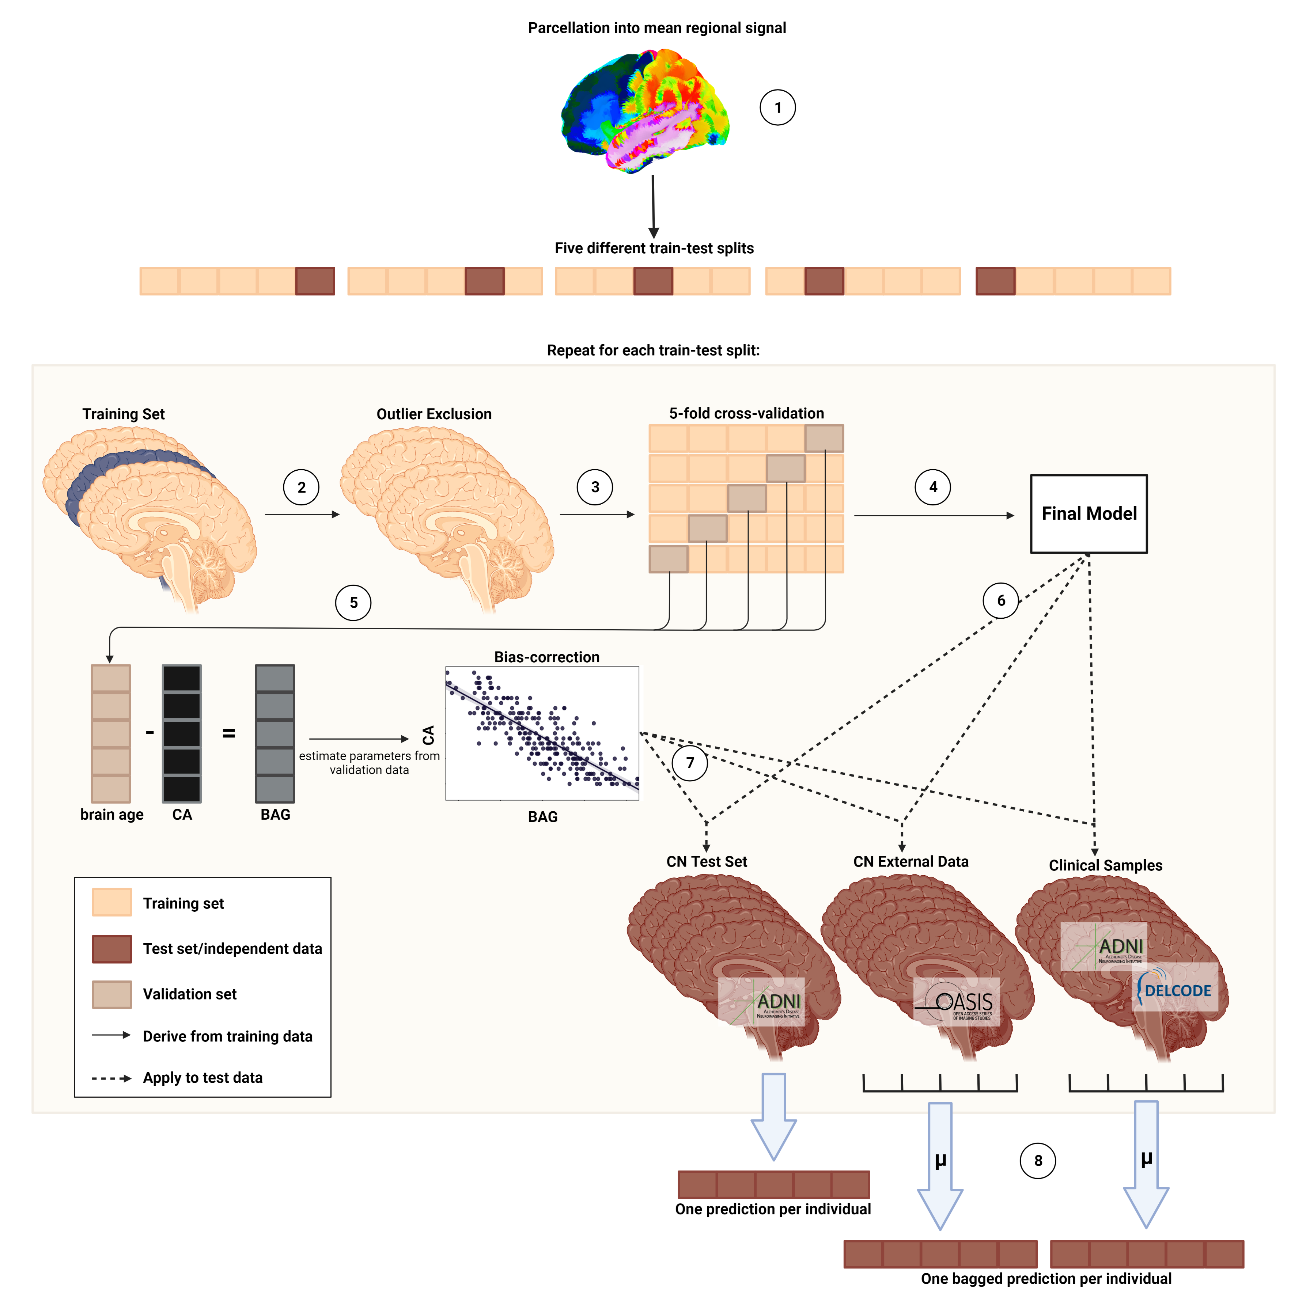

As a result of the nested CV approach, we obtained five final models per modality. Thus, per modality, we obtained one brain age estimate per (non-outlier) subject in the CNADNI sample, and five estimates per subject in the OASIS and patient samples. In the OASIS and patient samples, the average of the five estimates was treated as the final brain age estimate (*bagging*). The feature importance (δ) of each brain region was assessed by considering the learned weights of the final models.

**2.4 Statistical analyses**

BAG was calculated for each individual as the difference between brain age and chronological age, such that higher bag reflected more advanced brain age. The accuracy of brain age estimation from MRI or FDG-PET was assessed by comparing the MAE of brain age estimations from the two modalities using a paired t-test in the CNADNI sample. To assess generalizability of our brain age frameworks, we compared the MAE between CNADNI and CNOASIS by means of a standard t-test, using either MRI or FDG-PET as input for brain age estimation. To assess advancement of brain age in the clinical samples, we compared the average BAG and MAE, respectively, between CNADNI and each clinical cohort.

To further understand the differences of brain age estimation from MRI or FDG-PET, we assessed the Pearson correlation of BAG and of average feature importance (δ) over all cross-validation folds across modalities. Feature importance was assessed using permutation importance, which measures the impact of shuffling a feature's values on a model's performance, indicating the feature's importance to the model. We further summarized brain regions’ feature importance per modality into median signal in lobes (frontal, temporal, limbic, subcortical, occipital, parietal, see SM section XX), hemispheres (left, right) and lobes-by-hemisphere to assess whether brain regions of a particular lobe, hemisphere, or lobe-by-hemisphere were preferential for brain age estimation.

To assess whether BAG is associated with cognitive performance, we calculated partial correlations between BAG and composite scores of memory (ADNI-MEM14) and executive function (ADNI-EF15). In addition, partial correlations of BAG with PET amyloid load (AV45-PET), cerebrospinal fluid (CSF) markers of beta-amyloid1-42 (CSF Aβ1-42) and p-Tau181-to-Aβ1-42 ratio (p-Tau181/Aβ1-42) were calculated to assess whether BAG is associated with AD neuropathology. Correlations were computed for CNADNI, SCDADNI and MCIADNI. The method of correlation (Pearson or Spearman) was decided based upon normality assessment as per Shapiro-Wilk test and all partial correlations were corrected for age, sex, years of education and APOE-ε4 carriership. Significance levels were as follows: p < .1 = “trend significant”, p < .05 = “significant”, p < Bonferroni correction = “significant after Bonferroni correction” (cognitive performance: α = 0.05/2, AD neuropathology: α = 0.05/3). Descriptions of the variables assessed are provided in SM sections 1f and 1g.

Finally, we aimed to assess the prognostic value of the brain age gap for cognitive outcome in comparison to existing biomarkers. All BAG assessments took place at baseline. We differentiated between cognitively “stable” individuals, who maintained their baseline diagnosis until the two-year follow-up screening, and “decliners”, who received a diagnosis of (more severe) cognitive impairment within two years after baseline. Due to the small number of decliners in the CNADNI (n=16≙10%) and SCDADNI samples (n=10≙12%), we combined the two groups to a cognitively unimpaired (CUADNI) cohort. First, we computed an analysis of covariance of BAG between individuals with and without impending cognitive impairment, while correcting for sex, years of education and APOE-ε4 carriership in CNADNI and SCDADNI, and age, sex, years of education and APOE-ε4 carriership in MCIADNI (where a bias remained when BAG was estimated from MRI). Subsequently, we trained multiple single-feature logistic regression classifiers in a stratified ten-fold cross-validated manner to predict cognitive outcome in different cognitive groups from FDG-PET BAG, MRI BAG, hippocampal volume, global AV45-PET SUVr, FDG-PET SUVr in the precuneus, p-tau181/Aβ1-42 ratio, mini mental state exam score or chronological age (total models per group = 8). MRI and FDG-PET measures were derived from the AAL parcellation. Global AV45-PET was taken from publicly available prior analyses16. To correct for the effects of age, sex, years of education, and APOE status, standardized residuals were calculated for each predictor variable in the analysis. Standardized residuals were computed using a linear model trained on the stable individuals in each training fold, which was subsequently applied to all training and validation data of the current fold17. Age was not corrected for when age or BAG (in CUADNI) were the predictor of cognitive outcome. These standardized residuals were then used as the predictor variables in subsequent statistical analyses. We compared the mean area under the curve (AUC) obtained from the validation folds across all predictors. If BAG of one modality showed comparable performance to the best biomarkers, we derived a cut-off given the a priori probability of cognitive decline in each training fold, and we validated this cut-off in available external datasets.

**3 Results**

**3.1 Participants**

An overview of participant characteristics is shown in **Table 1**. CNOASIS, SCDADNI and SCDDELCODE subjects were significantly younger compared to the main CNADNI cohort. The SCD and MCI cohorts further differed from CNADNI in terms of cognitive performance (MCIADNI and MCIDELCODE), years of education (SCDADNI and MCIDELCODE), amyloid status (SCDDELCODE and MCIADNI) and APOE-ε4 carriership (MCIADNI and MCIDELCODE). Bias correction successfully eliminated the correlation of BAG and age with the exception of MRI-derived BAG in MCI (Table SM2).

**3.2 Accuracy and demographic profile of estimated brain age**

MRI- and FDG-PET estimated brain age comparably well in CNADNI (MAEMRI = 2.49, MAEFDG-PET = 2.60), CNOASIS (MAEMRI = 2.92, MAEFDG-PET = 2.54) and SCDADNI (MAEMRI  = 2.50, MAEFDG-PET = 2.56), while the MAE of MRI-derived brain age (MAEMRI = 3.30) was significantly higher compared to FDG-PET (MAEFDG-PET = 2.59; **Table 2**). Within-modality comparison of MAE in CNOASIS and CNADNI yielded no significant differences, thus suggesting high generalization performance of our frameworks to external datasets comprising CN populations. However, the R² value of MRI-derived brain age was only 0.42 in CNOASIS compared to 0.74 in CNADNI and FDG-PET-derived brain age showed significantly higher BAG in CNOASIS compared to CNADNI. FDG-PET-, but not MRI-derived brain age was trend significantly advanced in SCDADNI (MEMRI = 0.11, MEFDG-PET = 0.64). In all other clinical cohorts brain age was significantly advanced compared to CNADNI (SCDDELCODE: MEFDG-PET = 2.77; MCIADNI: MEMRI = 2.16, MEFDG-PET = 0.55; MCIDELCODE: MEMRI = 2.89).

BAG was trend significantly correlated between MRI- and FDG-PET-based models (r = .128, *p* = .09, 95% CI [-0.02, 0.27]). Model selection returned different model types with mostly linear kernels (see Table SM1). Bilateral hippocampi were most relevant for brain age estimation from MRI (δleft_hippocampus = 0.098, δright_hippocampus = 0.103), while median permutation in lobes, hemispheres or lobes-by-hemisphere showed no obvious trends (**FIGURE 2**). Especially subcortical regions (δsubcortical = 0.058, δleft_subcortical = 0.058, δright_subcortical = 0.067), and, to a lesser extent also left-hemispheric frontal (δleft_frontal = 0.013) and temporal regions (δleft_temporal = 0.012) were most relevant for brain age estimation from FDG-PET. No overall hemispheric preference was observed for FDG-PET models. Average regional importance was not correlated between MRI- and FDG-PET-based models (r = -.069, p = .52, 95% CI [-0.27, 0.14]).

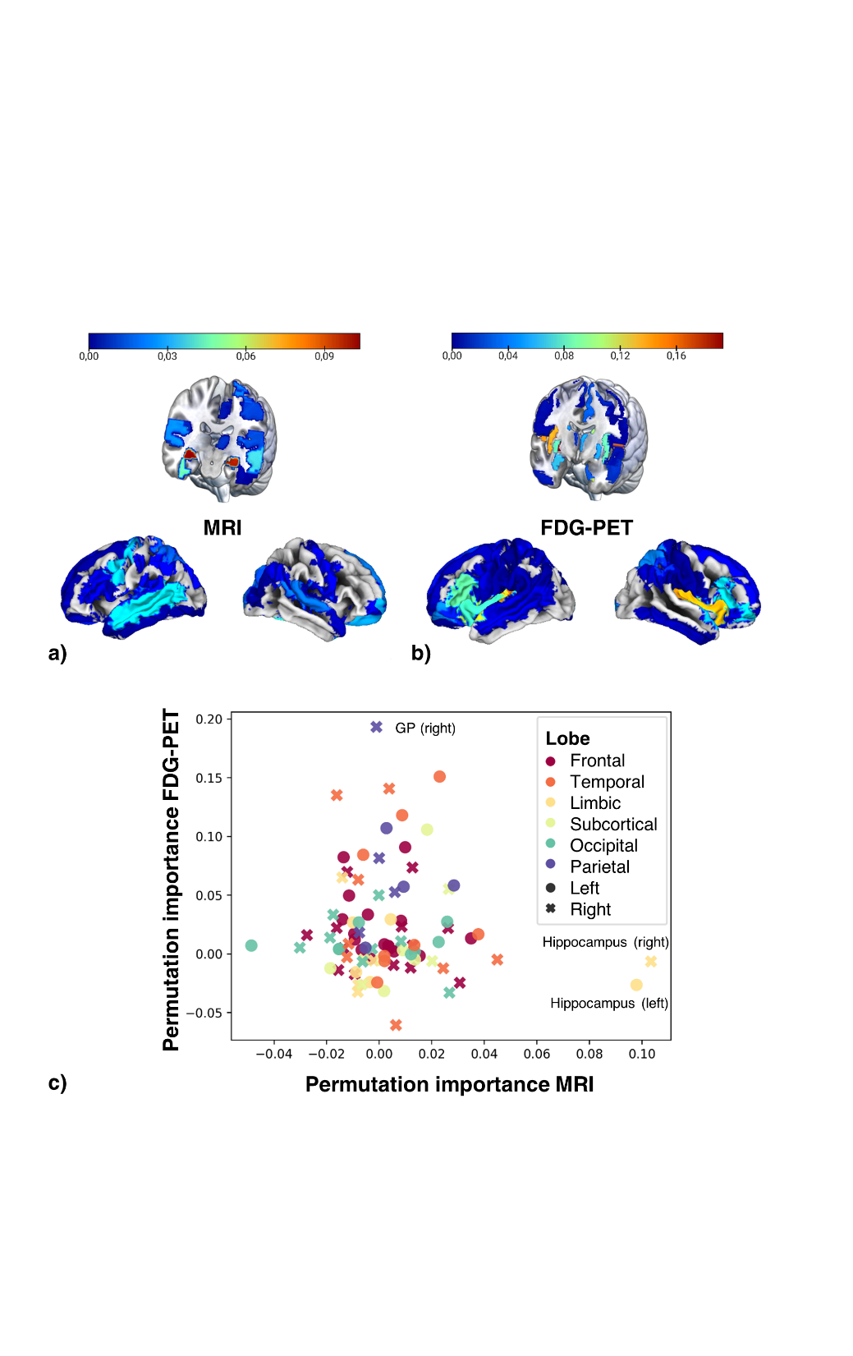 **3.3 BAG and cognitive performance**

**FIGURE 2** **Feature importance for brain age prediction.** a) Average regional importance for brain age prediction using MRI (thresholded at 0 for visibility). b) Average weights for brain age prediction using FDG-PET (thresholded at 0 for visibility). More relevant weights are depicted in red. c) Scatter plot of average feature importance in FDG-PET and MRI by lobe (colors) and hemisphere (shapes).

In CNADNI, neither MRI-, nor FDG-PET BAG were associated with executive function or memory performance (**CN**: n=154, *ADNI-EF*: rMRI = .016, p = .84, 95% CI [-.14, .18]; rFDG-PET = .100, p = .22, 95% CI [-.06, .26]; *ADNI-MEM*: rMRI = -.001, p = .99, 95% CI [-.16, .16]; rFDG-PET = .095, p = .25, 95% CI [-.07, .25]; **CU**: n=237, *ADNI-EF*: rMRI = .023, p = .73, 95% CI [-.11, .15]; rFDG-PET = -.019, p = .77, 95% CI [-.15, .11]; *ADNI-MEM*: rMRI = -.048, p = .46, 95% CI [-.18, .08]; rFDG-PET = -.015, p = .82, 95% CI [-.14,0.11]). In SCDADNI, FDG-PET BAG was significantly negatively associated with memory performance after Bonferroni correction, and trend significantly with executive function. MRI BAG was not correlated with these measures (n=83, *ADNI-EF*: rMRI = .048, p = .68, 95% CI [-.18, .27]; rFDG-PET = -.190, p = .09, 95% CI [-.39, .03]; *ADNI-MEM*: rMRI = -.132, p = .25, 95% CI [-.34, .09]; rFDG-PET = -.259, p = .02, 95% CI [-.45, -.04]). In MCIADNI, both, MRI- and FDG-PET-derived BAG were significantly negatively correlated with executive function and memory performance after Bonferroni correction (n=460, *ADNI-EF*: rMRI = -.225, p < .001, 95% CI [-.31, -.14]; rFDG-PET = -.238, p < .001, 95% CI [-.32, -.15]; *ADNI-MEM*: rhoMRI = -.397, p < .001, 95% CI [-.47, .32]; rhoFDG-PET = -.179, p < .001, 95% CI [-.27, -.09], **FIGURE 3**).

**3.4 BAG and AD neuropathology**

In CNADNI, BAG and AD neuropathology were not significantly correlated although PET BAG tended to be elevated with the presence of pathology in CSF(*AV45-PET* (n=148): rhoMRI = -.002, p = .97, 95% CI [-.17, .16]; rhoFDG-PET = .011, p = .90, 95% CI [-.15, .17]; *CSF Aβ1-42* (n=133): rhoMRI = .003, p = .97, 95% CI [-.17, .18]; rhoFDG-PET = -.110, p = .21, 95% CI [-.28, .06]; *p-Tau181/Aβ1-42* (n=132): rhoMRI = .029, p = .75, 95% CI [-.15, .20]; rhoFDG-PET = .141, p = .11, 95% CI [-.03, .31]). In SCDADNI, lower levels of amyloid in CSF were significantly associated with increased MRI BAG, while higher amyloid load in PET was trend significantly associated with elevated FDG-PET BAG (*AV45-PET* (n=82): rhoMRI = .014, p = .91, 95% CI [-.21, .24]; rhoFDG-PET = .191, p = .09, 95% CI [-.03, .40]; *CSF Aβ1-42* (n=77): rMRI = -.238, p = .04, 95% CI [-.44, -.01]; rFDG-PET = -.161, p = .17, 95% CI [-.38, .07]; *p-Tau181/Aβ1-42* (n=77): rhoMRI = .017, p = .89, 95% CI [-.21, .25]; rhoFDG-PET = .087, p = .46, 95% CI [-.15, .31]). In MCIADNI, MRI BAG was at least trend significantly correlated with all three markers of AD neuropathology. FDG-PET BAG was also associated with pathology markers, but only those obtained from CSF (*AV45-PET* (n=326): rhoMRI = .095, p = .09, 95% CI [-.01, .02]; rhoFDG-PET = .056, p = .32, 95% CI [-.05, .16]; *CSF Aβ1-42* (n=376): rhoMRI = -.230, p < .001, 95% CI [-.32, -.13]; rhoFDG-PET = -.126, p = .02, 95% CI [-.22, -.02]; *p-Tau181/Aβ1-42* (n=376): rhoMRI = .200, p < .001, 95% CI [.10, .30]; rhoFDG-PET = .101, p = .052, 95% CI [-.00, .20], **FIGURE 3**).

**FIGURE 3 Correlation of BAG with cognitive performance (a) and AD neuropathology in MCI.** XX

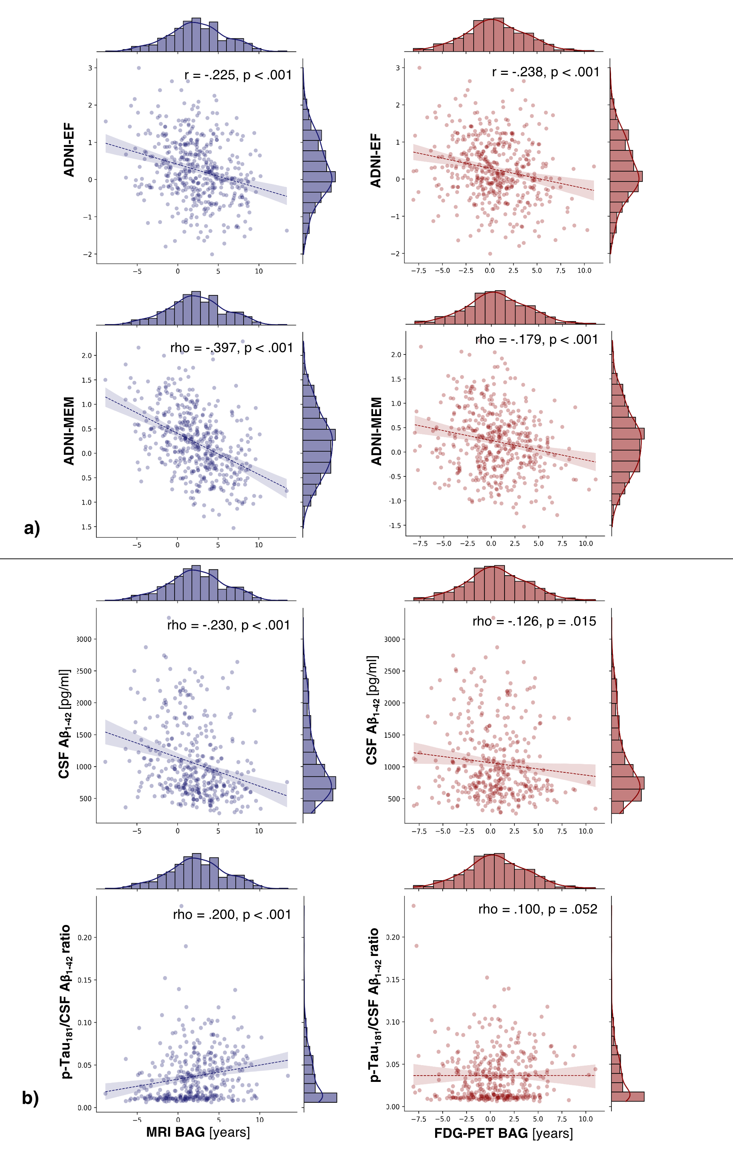

**3.5 BAG and Cognitive Outcome**

To test the prognostic potential of MRI- or FDG-PET-derived BAG, we first conducted an ANCOVA to examine the difference of baseline MRI and FDG-PET BAG, respectively, between stables and decliners while controlling for sex, years of education, and APOE carriership. In SCDADNI and CUADNI, brain age was higher in decliners compared to stables, although this effect was not significant and not observed in CNADNI (**CNADNI**: MRI BAG: F(1, 149) = 0.617, *p* = .43; FDG-PET BAG: F(1, 149) = 0.023, *p* = .88; **SCDADNI**: MRI BAG: F(1, 78) = 0.247, *p* = .62; FDG-PET BAG: F(1, 78) = 1.66, *p* = .20; CUADNI: MRI BAG: F(1, 232) = 0.870, *p* = .35; FDG-PET BAG: F(1, 232) = 0.619, *p* = .43, **FIGURE 4** a and SM FIGURE 1 for CNADNI and SCDADNI), suggesting that there was no difference in baseline BAG between stables and decliners. However, there was a significant covariate effect of sex on baseline MRI BAG (F(1, 232) = 18.92, *p* < .001), indicating that sex was associated with baseline BAG. In MCIADNI, we found a significant main effect of group for both, MRI and FDG-PET BAG (MRI BAG: F(1, 454) = 59.64, *p* < .001; FDG-PET BAG: F(1, 454) = 10.18, *p* = .002), with decliners showing advanced baseline BAG (MMRI = 4.51, SDMRI = 2.79; MFDG-PET = 1.35, SDFDG-PET = 3.38) compared to stable individuals (MMRI = 1.58, SDMRI = 3.40; MFDG-PET = 0.31, SDFDG-PET = 3.14; **FIGURE 4** b).

Next, we trained a logistic regression classifier to predict cognitive outcome within two years from baseline BAG using (age), sex, education and APOE-residualized biomarkers as predictors. We found that only ADNI-MEM (AUC = .77) and hippocampal volume (AUC = .74), but not MRI (AUC = .56) or FDG-PET BAG (AUC = .63) predicted cognitive outcome in CUADNI. In MCIADNI, on the other hand, MRI BAG predicted cognitive outcome (AUC = .73), as did ADNI-MEM (AUC = .78), AV45-PET (AUC = .77), hippocampal volume (AUC = .75) and p-Tau181/Aβ ratio (AUC = .70). FDG-PET BAG (AUC = .60). From a priori probabilities of cognitive decline in each training fold, we derived a mean probability cut-off for MRI-BAG prediction of cognitive outcome of .25 (range: .24 – .25). This cut-off yielded sensitivities and specificities of .69 and .69 in MCIADNI and .69 and .62 in MCIDELCODE (AUC of MRI BAG-derived cognitive outcome = .75). All AUCs are shown in **FIGURE 4** c).

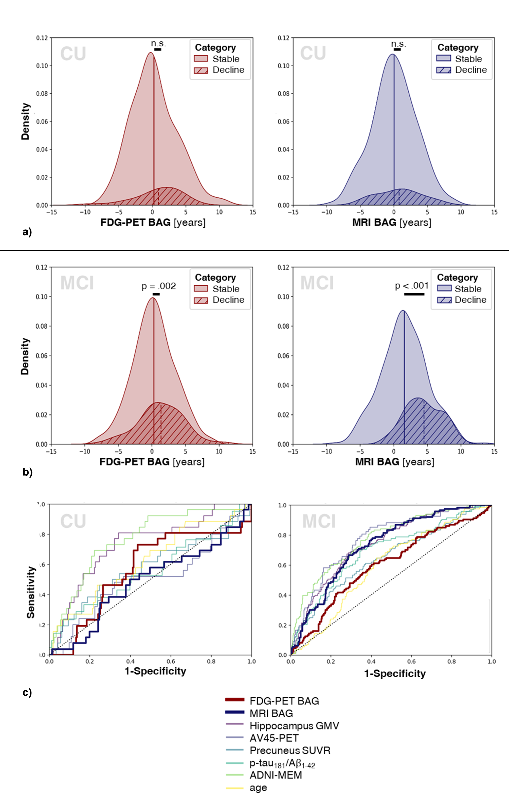

**FIGURE 4 BAG for the Prediction of Cognitive Outcome.** Density plots showing MRI and BAG distribution by cognitive outcome in CUADNI (a)) and MCIADNI (b)). c) Results from ten-fold stratified cross-validation to predict cognitive outcome from residualized features.

**4 Discussion**

Previous studies have mainly used MRI to estimate brain age. FDG-PET is an early indicator of neurodegeneration-related cerebral changes and a recent study showed for the first time that it could also be used successfully to estimate brain age1. Here, we compared the accuracy of FDG-PET and MRI-estimated brain age and provided a comprehensive overview of the cognitive and neuropathological profile of FDG-PET and MRI-derived BAG in different cognitive groups. We showed that 1) MRI and FDG-PET both accurately estimated brain age; 2) FDG-PET-derived BAG better reflected cognitive variance in SCD, while both, MRI and FDG-PET BAG reflected cognitive performance in MCI; 3) MRI and FDG-PET BAG are differentially associated with markers of amyloid in cognitively unimpaired individuals, and more consistently with markers of amyloid and p-Tau in MCI. Finally, we showed that MRI-derived BAG holds prognostic value that generalizes across datasets and is competitive to state-of-the-art biomarkers of cognitive decline in MCI.

Our findings suggest that advanced brain age captures brain health, in the form of cognitive and neuropathological variance in the early AD continuum as early as the SCD stage. The observed negative association between FDG-PET BAG and memory performance may suggest that FDG-PET BAG has the capacity to detect subtle cognitive decline at its nascent stages, even before it becomes clinically manifest. Notably, this inference is bolstered by the marginal elevation of FDG-PET BAG, which was not observed on MRI, in individuals with SCD relative to CN. Additionally, while the difference in BAG between decliners and stables did not reach statistical significance, there was a discernible trend towards higher FDG-PET BAG in the former group, which may become significant with a bigger sample size of SCD. These observations provide preliminary evidence for the utility of FDG-PET BAG as a potential early biomarker for cognitive impairment. As SCD becomes increasingly recognized as constituting the earliest stage of the AD continuum, the scientific community is now collecting increasing amounts of data for this cognitive group, which could allow to validate these observations with bigger sample sizes in the future.

While previous work has outlined the association of brain age advancement and cognitive outcome in CU and MCI1, we have shown that the advancement of brain age on MRI is predictive of progression to dementia in MCI with performance even after correction for confounding factors. Notably, none of the predictors reached sufficient performance to recommend them as a stand-alone prognostic biomarker in MCI. Notably, performance of MRI BAG was *en pars* with established AD biomarkers, such as amyloid PET, composite memory performance and hippocampal volume. MRI BAG estimation was strongly, but not exclusively based on hippocampal volume, thus, in comparison, MRI BAG provides the opportunity to quantify neurodegeneration beyond this brain structure into a single number. It is worth mentioning that none of the individual biomarkers achieved high predictive performance, when confounding factors were controlled for. Thus, more research into prognostic biomarkers for AD is required and our findings show that MRI BAG could possibly complement patient stratification in clinical trials of this manner. Moreover, BAG could potentially provide useful information on drug efficacy21.

Similar to previous studies1,4, we found differences in brain regions displaying aging as observed on FDG-PET and MRI. Thus, different aging processes may be observed depending on the modality, which underlines the importance of considering the appropriate modality for a research question. The regions deemed most important by our MRI and FDG-PET models have previously been described to be substrates heavily affected by aging4. The greater left-hemisphere involvement in brain age estimation on MRI compared to FDG-PET could explain the better association of MRI-derived BAG with AD biomarkers and cognitive outcome in MCI, as the left hemisphere is known to be affected early on in AD aetiology22. Given the overall strong association of regions deemed important for brain age estimation with AD, our work further supports the claim that AD-related neurodegeneration, at least in part, resembles a form of advanced brain aging.

Some limitations should be acknowledged. First, due to data availability and increased risk of cognitive deficits being due to neurodegenerative processes23, we only included participants over the age of 60, however, accelerated aging starting before this age remained uninvestigated in our study. Moreover, there is a lack of publicly available big neuroimaging databases on SCD, enabling to disentangle early differences in brain health, possibly related to cognitive decline, between CN and SCD. The SCD label was only included in the second phase of the ADNI study – individuals recruited during ADNI-1 (~1/4 of our sample) may therefore have had SCD which was undetected at the time and which possibly caused the indifferent results of brain age between CN and SCD in the ADNI sample. However, exclusion of these individuals would have caused further shrinkage of our sample size, which would have been undesirable. Furthermore, the sensitivity and especially specificity values for prognoses of cognitive outcome are not high enough to use these measures as standalone biomarkers of cognitive outcome. Moreover, obtaining FDG-PET scans from a cognitively unimpaired population is not straightforward, as it requires logistical availability, high cost, and the injection of a radioactive tracer in the absence of evident cognitive impairment. However, accurate prognoses, particularly for cognitively unimpaired individuals, are difficult to establish and we believe that BAG assessment with a group-dependent choice of modality can aid this process by providing a first indicator of cognitive outcome. Future work should evaluate the combined potential of FDG-PET BAG and APOE-ε4 carriership as a prognostic biomarker of cognitive outcomes. Second, the different FDG-PET scanning protocol of DELCODE (acquisition time: 40-60 min post injection) compared to ADNI and OASIS (acquisition time: 30-60 min post injection) might have influenced generalization of our models to the DELCODE cohort. Yet, we believe that the difference would not be substantial, as we averaged time frames over the entire acquisition time. Moreover, the average BAG (ME) of SCDDELCODE exceeds the previously reported BAG on MRI (1.1 years24), and the MRI and FDG-PET BAG of MCI patients in our analyses. These differences may be driven by methodological differences, including substantially younger age compared to the study by Rockiki et al., which likely lowers the risk of these individuals to be incipient AD patients, and a different choice of modality (MRI instead of FDG-PET). Whether the FDG-PET BAG is abnormally high in our analyses, or whether higher FDG-PET BAG in SCD reflects very early neurological dysfunction needs further investigation. XX GENERALIZATION TO EXTERNAL DATA XX

In summary, we have shown that MRI and FDG-PET can both be used to estimate brain age and, with some respects, show different benefits depending on the group analyzed: While MRI- and FDG-PET BAG both accurately reflect neuropathological burden across groups and cognitive performance in MCI, only FDG-PET BAG can aid in the prognosis of cognitive outcome in cognitively unimpaired individuals. On the other hand, MRI-derived BAG demonstrates a better estimate for dementia risk in MCI. Estimating cognitive outcome using our BAG cutoffs could complement the identification of patients in need of frequent monitoring at an early time point of cognitive decline and could support clinical trials, both methodologically and financially.

**Author Contributions**

All authors contributed to the study conception and design. Material preparation, data collection and analysis were performed by ElD and GA, with support from KRP and MCH. KRP, TvE, SBE and AD jointly supervised this work. DELCODE data preparation was supervised by MD and HB (PET), EmD (MRI) and FJ (clinical data). The first draft of the manuscript was written by ED and all authors commented on previous versions of the manuscript. All authors read and approved the final manuscript.

**Acknowledgements**

The authors gratefully acknowledge data gathering and provision by the ADNI, OASIS and DELCODE studies for the preparation of this manuscript. The authors further thank the Interdisciplinary Program Molecular Medicine at the University of Cologne (IPMM) for their continued support.

**Disclosure**

KRP and SBE were partly supported by the Deutsche Forschungsgemeinschaft (DFG, PA 3634/1-1 and EI 816/21-1). MCH received funding from the Alzheimer Forschung Initiative. This work was partly supported by the Helmholtz Portfolio Theme “Supercomputing and Modelling for the Human Brain".

Data collection and sharing for this project was funded by the ADNI (National Institutes of Health Grant U01 AG024904) and DOD ADNI (Department of Defense award number W81XWH-12-2-0012). ADNI is funded by the National Institute on Aging, the National Institute of Biomedical Imaging and Bioengineering, and through generous contributions from the following: AbbVie, Alzheimer's Association; Alzheimer's Drug Discovery Foundation; Araclon Biotech; BioClinica, Inc.; Biogen; Bristol-Myers Squibb Company; CereSpir, Inc.; Cogstate; Eisai Inc.; Elan Pharmaceuticals, Inc.; Eli Lilly and Company; EuroImmun; F. Hoffmann-La Roche Ltd and its affiliated company Genentech, Inc.; Fujirebio; GE Healthcare; IXICO Ltd.;Janssen Alzheimer Immunotherapy Research & Development, LLC.; Johnson & Johnson Pharmaceutical Research & Development LLC.; Lumosity; Lundbeck; Merck & Co., Inc.;Meso Scale Diagnostics, LLC.; NeuroRx Research; Neurotrack Technologies; Novartis Pharmaceuticals Corporation; Pfizer Inc.; Piramal Imaging; Servier; Takeda Pharmaceutical Company; and Transition Therapeutics. The Canadian Institutes of Health Research is providing funds to support ADNI clinical sites in Canada. Private sector contributions are facilitated by the Foundation for the National Institutes of Health ([www.fnih.org](https://ida.loni.usc.edu/collaboration/access/www.fnih.org)). The grantee organization is the Northern California Institute for Research and Education, and the study is coordinated by the Alzheimer's Therapeutic Research Institute at the University of Southern California. ADNI data are disseminated by the Laboratory for Neuro Imaging at the University of Southern California.

The DELCODE study was funded by the German Center for Neurodegenerative Diseases (Deutsches Zentrum für Neurodegenerative Erkrankungen, DZNE: reference number BN012).

**Key Points**

**QUESTION:** What is the neuropathological and predictive profile of brain age gaps (BAGs) derived from structural MRI or FDG-PET?

**PERTINENT FINDINGS**: BAG was computed from structural MRI and FDG-PET and subsequently associated with neuropathological markers of Alzheimer’s disease, as well as risk of cognitive deterioration. While both, MRI- and FDG-PET-derived BAG were indicative of existing amyloid pathology already in individuals without cognitive impairment, the predictive capacity of BAG for cognitive outcome was group-dependent: FDG-PET-derived BAG predicted cognitive deterioration in cognitively unimpaired individuals and MRI-derived BAG predicted cognitive deterioration in patients with mild cognitive impairment.

**IMPLICATIONS FOR PATIENT CARE:** A group-dependent choice of modality for BAG assessment can complement care management plans of cognitively unimpaired and impaired individuals by providing estimates of cognitive outcomes.

**References**

1. Lee J, Burkett BJ, Min H-K, et al. Deep learning-based brain age prediction in normal aging and dementia. *Nat Aging*. 2022;2:412–424. doi:10.1038/s43587-022-00219-7

2. Löwe LC, Gaser C, Franke K. The effect of the APOE genotype on individual BrainAGE in normal aging, Mild cognitive impairment, and Alzheimer’s Disease. *PLoS One*. 2016;11(7):e0157514. doi:10.1371/journal.pone.0157514

3. Gaser C, Franke K, Klöppel S, Koutsouleris N, Sauer H. BrainAGE in Mild Cognitive Impaired Patients: Predicting the Conversion to Alzheimer’s Disease. *PLoS One*. 2013;8(6):e67346. doi:10.1371/journal.pone.0067346

4. Dukart J, Kherif F, Mueller K, et al. Generative FDG-PET and MRI Model of Aging and Disease Progression in Alzheimer’s Disease. *PLoS Comput Biol*. 2013;9(4):e1002987. doi:10.1371/journal.pcbi.1002987

5. LaMontagne PJ, Benzinger TLS, Morris JC, et al. OASIS-3: Longitudinal neuroimaging, clinical, and cognitive dataset for normal aging and Alzheimer disease. *medRxiv*. Published online 2019. doi:10.1101/2019.12.13.19014902

6. Jessen F, Spottke A, Boecker H, et al. Design and first baseline data of the DZNE multicenter observational study on predementia Alzheimer’s disease (DELCODE). *Alzheimer’s Res Ther*. 2018;10(1):15. doi:10.1186/s13195-017-0314-2

7. Jessen F, Amariglio RE, Van Boxtel M, et al. A conceptual framework for research on subjective cognitive decline in preclinical Alzheimer’s disease. *Alzheimer’s Dement*. 2014;10(6):844-852. doi:10.1016/j.jalz.2014.01.001

8. Albert MS, DeKosky ST, Dickson D, et al. The diagnosis of mild cognitive impairment due to Alzheimer’s disease: Recommendations from the National Institute on Aging-Alzheimer’s Association workgroups on diagnostic guidelines for Alzheimer’s disease. *Alzheimer’s Dement*. 2011;7(3):270-279. doi:10.1016/j.jalz.2011.03.008

9. Jack CR, Bernstein MA, Fox NC, et al. The Alzheimer’s Disease Neuroimaging Initiative (ADNI): MRI methods. *J Magn Reson Imaging*. 2008;27(4):685-691. doi:10.1002/jmri.21049

10. Pedregosa F, Varoquaux G, Gramfort A, et al. Scikit-learn: Machine learning in Python. *J Mach Learn Res*. 2011;12:2825-2830. Accessed April 20, 2021. http://scikit-learn.sourceforge.net.

11. Tzourio-Mazoyer N, Landeau B, Papathanassiou D, et al. Automated anatomical labeling of activations in SPM using a macroscopic anatomical parcellation of the MNI MRI single-subject brain. *Neuroimage*. 2002;15(1). doi:10.1006/nimg.2001.0978

12. Beheshti I, Ganaie MA, Paliwal V, Rastogi A, Razzak I, Tanveer M. Predicting Brain Age Using Machine Learning Algorithms: A Comprehensive Evaluation. *IEEE J Biomed Heal Informatics*. 2022;26(4):1432-1440. doi:10.1109/JBHI.2021.3083187

13. Beheshti I, Nugent S, Potvin O, Duchesne S. Bias-adjustment in neuroimaging-based brain age frameworks: A robust scheme. *NeuroImage Clin*. 2019;24:102063. doi:10.1016/j.nicl.2019.102063

14. Crane PK, Carle A, Gibbons LE, et al. Development and assessment of a composite score for memory in the Alzheimer’s Disease Neuroimaging Initiative (ADNI). *Brain Imaging Behav*. 2012;6(4):502-516. doi:10.1007/s11682-012-9186-z

15. Gibbons LE, Carle AC, Mackin RS, et al. A composite score for executive functioning, validated in Alzheimer’s Disease Neuroimaging Initiative (ADNI) participants with baseline mild cognitive impairment. *Brain Imaging Behav*. 2012;6(4):517-527. doi:10.1007/s11682-012-9176-1

16. Landau S, Jagust W. *Florbetapir Processing Methods*.; 2011.

17. Dukart J, Schroeter ML, Mueller K. Age correction in Dementia - Matching to a healthy brain. *PLoS One*. 2011;6(7). doi:10.1371/journal.pone.0022193

18. Ranganathan P, Pramesh C, Aggarwal R. Common pitfalls in statistical analysis: Logistic regression. *Perspect Clin Res*. 2017;8(3):148-151. doi:10.4103/picr.PICR_87_17

19. Parfenov VA, Zakharov VV, Kabaeva AR, Vakhnina NV. Subjective cognitive decline as a predictor of future cognitive decline a systematic review. *Dement e Neuropsychol*. 2020;14(3):248-257. doi:10.1590/1980-57642020dn14-030007

20. Cole JH, Marioni RE, Harris SE, Deary IJ. Brain age and other bodily ‘ages’: implications for neuropsychiatry. *Mol Psychiatry*. 2019;24(2):266-281. doi:10.1038/s41380-018-0098-1

21. Van Gestel H, Franke K, Petite J, et al. Brain age in bipolar disorders: Effects of lithium treatment. *Aust N Z J Psychiatry*. 2019;53(12):1179-1188. doi:10.1177/0004867419857814

22. Pfeil J, Hoenig MC, Doering E, van Eimeren T, Drzezga A, Bischof GN. Unique regional patterns of amyloid burden predict progression to prodromal and clinical stages of Alzheimer’s disease. *Neurobiol Aging*. 2021;106:119-129. doi:10.1016/j.neurobiolaging.2021.06.014

23. Jessen F, Amariglio RE, Buckley RF, et al. The characterisation of subjective cognitive decline. *Lancet Neurol*. 2020;19(3). doi:10.1016/S1474-4422(19)30368-0

24. Rokicki J, Wolfers T, Nordhøy W, et al. Multimodal imaging improves brain age prediction and reveals distinct abnormalities in patients with psychiatric and neurological disorders. *Hum Brain Mapp*. 2021;42(6):1714-1726. doi:10.1002/hbm.25323

|  |  |  |  |  |  |  |
| --- | --- | --- | --- | --- | --- | --- |
| **Table 1.** Overview of samples | | | | | | |
|  | CNADNI | CNOASIS | SCDADNI | MCIADNI | SCDDELCODE | MCIDELCODE | |
| *n* total | 186 | 49 | 102 | 595 | 88 | 80 | |
| Age at PET scan [avg. years (SD)] | 73.8 (6.46) | 70.6 (5.07)+ | 72.3 (5.60)+ | 73.2 (6.93) | 70.9 (5.57)+ | NA | |
| Age at MRI scan [avg. years (SD)] | 73.8 (6.44) | 69.2 (4.98)+ | 72.3 (5.60)+ | 73.2 (6.92) | NA | 73.4 (5.87) | |
| Sex [%female (nNA)] | 53 (0) | 53 (0) | 59 (0) | 42 (2)+ | 36 (0)+ | 36 (0)+ | |
| MMSE [avg. score] | 29 (1.26) | 29 (0.78) | 29 (1.20) | 28 (1.75)+ | 29 (1.03) | 28 (1.67)+ | |
| Education [avg. years (SD)] | 16 (2.54) | 16 (2.51) | 17 (2.50)+ | 16 (2.67) | 16 (3.00) | 14 (3.06)+ | |
| CSFAβ1-42 Status [%positive (nNA)] | 41 (27) | NA | 35 (9) | 64 (126)+ | 22 (28)+ | 38 (38) | |
| APOE [% ε4-carriers (nNA)] | 29 (1) | NA | 31 (0) | 49 (4)+ | 38 (3) | 49 (0)+ | |
| Notes. Percentage of CSFAβ1-42 status indicates percentage of amyloid positive individuals among all who received lumbar puncture (excluding NA). Thresholds for amyloid positivity was 1100 pg/ml in ADNI and 496 pg/ml in DELCODE. +significantly different from CNADNI as assessed per t-test (age, MMSE, education) or χ² (sex, amyloid status, APOE status). | | | | | | | |

|  |  |  |  |  |  |  |  |  |  |
| --- | --- | --- | --- | --- | --- | --- | --- | --- | --- |
| **Table 2.** Accuracy of estimating chronological age from FDG-PET and MRI scans using AAL atlas. | | | | | | | | | |
|  | Modality | *n* | MAE | Range | ME | R² | **Accuracy**  MAE MRI vs FDG-PET | **Generalizability**  MAE current vs CNADNI | **Brain age advancement**  MEcurrent vs CNADNI |
| **CNADNI** | MRI | 175+ | 2.49 | [-9.4, 8.7] | 0.06 | .74 | t = 0.48  95% CI [-0.33, 0.55] | NA | NA |
| FDG-PET | 175+ | 2.60 | [-10.1, 9.6] | -0.10 | .70 | NA |
| **CNOASIS** | MRI | 49+ | 2.92 | [-7.1, 8.4] | 0.13 | .42 | t = - 0.94  95% CI [-1.20, 0.43] | t = 1.16  95% CI [-0.31, 1.18] | t = 0.12  95% CI [-1.12, 1.26] |
| FDG-PET | 49+ | 2.54 | [-5.0, 6.8] | 0.89 | .63 | t = -0.18  95% CI [-0.64, 0.53] | t = 2.00*  95% CI [0.01, 1.97] |
| **SCDADNI** | MRI | 102 | 2.50 | [-6.6, 7.0] | 0.11 | .69 | t = 0.26 95% CI [-0.42, 0.54] | NA | t = 0.11  95% CI [-0.73, 0.82] |
| FDG-PET | 102 | 2.56 | [-5.6, 9.8] | 0.64 | .69 | NA | t = 1.86+  95% CI [-0.05, 1.53] |
| **MCIADNI** | MRI | 595 | 3.30 | [-10.5, 13.5] | 2.16 | .65 | t = -5.72**  95% CI [-0.95, 0.46] | NA | t = 7.47**  95% CI [1.55, 2.65] |
| FDG-PET | 595 | 2.59 | [-10.0, 11.0] | 0.55 | .78 | NA | t=2.23*  95% CI [0.08, 1.22] |
| **SCDDELCODE** | FDG-PET | 88 | 3.16 | [-2.7, 9.3] | 2.77 | .52 | NA | NA | t = 7.45**  95% CI [2.11, 3.63] |
| **MCIDELCODE** | MRI | 80 | 3.69 | [-5.1, 11.6] | 2.89 | .38 | NA | NA | t = 6.04**  95% CI [1.90, 3.75] |
| *Notes.* +After outlier exclusion using CN train set (IQR > 6). Accuracy differences were assessed with paired t-tests, while generalizability and brain age advancement were tested with standard t-tests. +trend significant with α = .1, * significant with α = .05, ** significant with α = .01 | | | | | | | | | |

1. + both authors contributed equally

   Data used in preparation of this article were obtained from the Alzheimer's Disease Neuroimaging Initiative (ADNI) database (adni.loni.usc.edu). As such, the investigators within the ADNI contributed to the design and implementation of ADNI and/or provided data but did not participate in analysis or writing of this report. A complete listing of ADNI investigators can be found at: <http://adni.loni.usc.edu/wp-content/uploads/how_to_apply/ADNI_Acknowledgement_List.pdf>